HOW TO GET AN “A” FOR YOUR ESSAY
Nan Bahr

HOW TO GET AN “A” FOR YOUR ESSAY …
Nan Bahr

Unpublished, Brisbane, Australia

Free if downloaded online www.promotingteachered.org

Provided at cost recovery in soft copy

Copyright © Nanette Margaret Bahr, 2026

The moral right of the author has been asserted
Copying is permitted with due attribution to the author

PREFACE
Do you often find yourself wondering why some people excel and earn high grades on their university assignments while you do not? Even though you understand the content and can articulate your perspective on issues in an informed way when asked—and you are often the first to respond to questions in class—you still rarely receive high grades on your term papers.
Well, this dummy’s guide is for you. In this handy dandy essay guide, we will explore essay structure, using and citing literature, tips for writing with authority, tools to help and check the impact of your writing, presentation, and many other tips and tricks. I include my Rule Book for writing and use examples throughout to illustrate the difference between adequate and mature essay work.
Why do I think I can help? Well, although I’m pretty much an average Joe with respect to my limited intellectual gifts, I have managed to accumulate multiple undergrad, post-grad and higher degrees, and have been an academic for over 30 years, reaching the dizzying heights of Emeritus Professor, and adjunct Professor at several Australian Universities, and I have over 200 academic publications. I have taught and assessed thousands of student submissions over the years and have mentored many more. I think as a student myself, I have had roughly 26 full-time years' equivalent of coursework broken into 52 semesters of study with approximately 3 written papers a semester … amounting to 156 written assignments just to kick off my career, and this was after finishing high school. But I didn’t figure out how to navigate essay writing successfully until my Doctoral dissertation, rather late in the day, actually.
So herein lies the guidance I could have relied upon back in the day. These are things I would have told my younger, less experienced self. These are secrets others seem to grasp naturally, but I needed to have them burned into me. I hope this helps you. A warning though, there are many ways to shell an onion, and this is just one way that has worked for me. I think having something is better than having nothing, so I hope my way is helpful for you.
For all those students who really want to do well but haven’t quite figured out how to manifest success.

Contents
Chapter 1: Preparing For Your Essay 3
Before You Start 3
Task Analysis 6
Ideas Generation 12
Chapter 2: Who Can Help? 15
Chapter 3: Starting Your Draft 18
Structuring And Sequencing 18
Linking And Leading 23
Chapter 4: Using Literature 25
To Quote Or Not To Quote 25
Good Literature And Bad Literature 25
Plug And Play Citations 26
Using Literature Without Plagiarism 27
Using Ai, Traps For New Players 27
Avoiding The Shopping List 28
Chapter 5: Finishing Touches 30
Spelling 30
Grammar 30
Citation Conventions 30
The Linking Game 30
Start At The End And Read Your Draft Backwards 32
Appendix A: Nan’s Rule Book 33
Postscript 34

Table of Figures

Figure 1 Clicking through to the full task description 5
Figure 2 ChatGPT generated mind map for the example assessment task 13
Figure 3 A network of support for you as you work on your assignment, 17
Figure 4 The outline structure for your essay 23
Figure 5 Conceptual linkages 31

CHAPTER 1: Preparing for your essay

Before you start
Alright, so you have an assignment to complete for your university course. Before you start writing, it’s essential to clarify a few things. What are you required to do, and by when? Find your course profile or ask your lecturer or tutor for details, take notes, and pay close attention to the answers to the following questions:
1. How many words/pages? Most written assignments or essays for a term paper typically range from 2,000 to 3,000 words. However, the first assignment in a course is often a shorter "taster" of around 400 to 800 words. A general guideline is 250 words per page, which helps you understand the volume of work expected.
2. Does the word limit include the reference list and citations? If they are included, this will significantly reduce your workload.
3. Check the course title. Ensure you understand the focus of the course. For example, if your course is called "Assessment in the Middle Ages," you should not start thinking about the Jurassic period. Getting the focus right from the beginning is critical, as overlooking this detail is a common mistake.
4. Is there a textbook, and is it required or preferred? If there is a textbook, you may not need to purchase it, but it’s wise to locate a copy. Review the plan for weekly reading in your course profile, paying particular attention to relevant chapters and pages scheduled in the learning activity plan before the assignment is due.
5. Has the lecturer provided guidance materials? Sometimes, lecturers provide a breakdown of the assignment or a cheat sheet outlining their expectations for each section regarding word allocation or questions to address. Utilize this as your primary guide.
6. Preferred format? Check for any formatting requirements, such as templates, guidance on headings, and expected appendices. This also includes technical specifications like file type and naming conventions. It’s unfortunate to lose marks for using the wrong format.
7. How will it be submitted? If your assignment is to be submitted online, ensure you have the necessary access. Also, check if you can submit drafts for similarity score previews.
8. Weighting? Understand what percentage of your overall course assessment this assignment represents. Is it 10%, or a larger percentage like 50% or more? Also, check if it’s a hurdle assessment (meaning you must pass it to pass the course).
9. Find and save the full task description. This will include a list of stated learning objectives for the course and the individual assignment, which are crucial for guiding your work.
10. How many references should you cite? Sometimes, there are expectations regarding the number of references.
11. Read the criteria sheet. Pay close attention to the descriptors for different grades. Understand how many criteria there are and how they will be assessed.
12. Restrictions or rules regarding AI usage. Review policies on the use of AI, including what is allowed and any specific requirements for reporting its use.
13. Due date and penalties. Be clear about when and where you need to submit your assignment. If there are classes before the due date, attend them—lecturers often share important information during this time. Check the penalties for late submissions: is there a gradual reduction in marks per day, or a strict zero-score policy?
14. Application for extension rules. Know how to apply for an extension if unexpected issues arise, like a computer malfunction or illness. Finding this out in a moment of crisis can be challenging.
15. Submitting drafts. Some lecturers or tutors allow the submission of drafts for feedback. It’s beneficial to know if this is an option in advance. If your lecturer doesn’t offer this support, you can seek assistance from a University Learning Adviser who can guide you through the task analysis.
16. File size limits. Lastly, check if there are any file size limits for uploading your assignment to avoid issues at the last moment. By addressing these points, you’ll set yourself up for a successful writing experience.
Most of the information you need can be found in one place: the course profile. Once you locate the course profile, be sure to select/go to the assessment heading/tab. This is where you will find the assignment task outline; however, you will require more information than what that provides. The next place to visit is to the more detailed summary of the assignment task, and there should also be the criteria sheet and marking rubric by digging a little further.
By finding the detailed task sheet and marking rubric/criteria, you will have gained an advantage over many of your classmates, who may be rushing through their assignments with only partial information. You can see in Figure 1 that there are at least four clicks in an electronic course profile for a university near me to reach the full task description for assignments. It’s a trap for young players who think they have all the information they need, but missed clicking through to the next, more detailed stage.
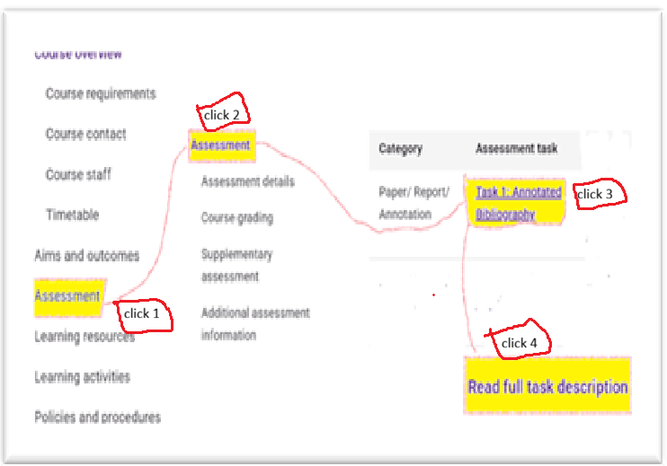
Figure 1 Clicking through to the full task description
Now that you’ve found all of the information about the set task, you are ready to start organising your thoughts. This is the time for you to carefully consider everything you’ve gathered about the assignment and its requirements. This is still before you actually start any writing at all. At this point, you should be in heavy task analysis mode.

Task analysis
Still at the preliminary stage, you need to analyse the set task very closely. You should be able to fill in any gaps from your first efforts to understand the assignment. First, you will need to understand what type of assessment it will be. There are many kinds of assessments: for example, these 25 assessment “types” are from the University of Queensland website:

Computer Code
Creative Production/ Exhibition
**Paper/ Report/ Annotation:
**Essay/ Critique
Examination
Notebook/ Logbook
Participation/ Student contribution
Performance
Placement
Portfolio
Poster
Practical/ Demonstration
Presentation
Product/ Design
**Project
Quiz
**Reflection
Role play/ Simulation
**Thesis
Translation/ Interpretation
Tutorial/ Problem Set

Each assessment type is unique and can be interpreted widely differently across disciplines, levels or stages of study, and even by different lecturers who have set the task. This handbook is designed to assist you with preparing assignments marked with **. Let’s have a practice. Imagine you’ve received this task [Text Box 1]. You should take a careful step-by-step approach to the task analysis.

Step 1: Administration aspects: marked with a yellow highlight
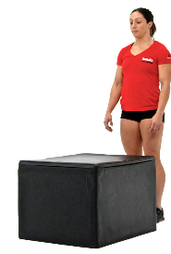
These are the general administrative details for the assignment. As you can see in Text Box 1, this information covers the assignment title, the assignment type category, and general submission expectations. A piece of information often overlooked is the course title and the assessment item title. Very often, students present their work on a topic that is completely off track. They do this because they have forgotten what the course is supposed to be about. The example task in Text Box 1 needs to be all about learning and development, even though it is barely mentioned in the task outline … simply because, well, that’s the course title, isn’t it?
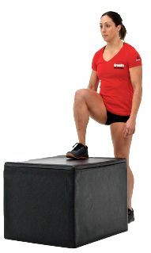
Step 2: Task description; marked with green highlight.

This is the directions for the task itself, what you basically need to do.

Step 3: Task restrictions, marked with a blue highlight
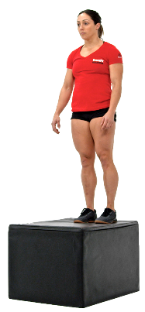
These are any qualifiers, any limits to the scope of the task.

Step 4: Tabularize this information (refer Figure 1)


This is your personal checklist to make sure you have attended to everything required. You will refer to it frequently.

Double-check that nothing important is missed.

Text Box 1: Task analysis
EDUCXXXX Learning and Development
Task 1: Annotated Bibliography
Mode: Written Category: Paper/ Report/ Annotation Weight: 30% 2000 words in total
Due date: 28/08/2025 2:00 pm
Other conditions: Student specific. See the conditions definitions
Learning outcomes: L01, L02, L04
Task description: For this task, you will present some contemporary literature on learning and development. You will need to find and discuss readings that focus on both of the following areas:
1) How secondary school students develop and learn in general (aspects of general learning theories discussed in the course)
2) The physical, social and intellectual/cognitive aspects of development and learning (one example for physical, social and cognitive learning in secondary schools each). Please make sure your chosen articles are about aspects of physical, social and cognitive learning and development in SECONDARY SCHOOL SETTINGS.
You will prepare an annotated bibliography including six references. You may use three readings included in this course (chapters/sections that are set for weekly readings, or any of the additional readings listed in the course profile), but you must use at least three other readings that you have found yourself. The three other readings that you find yourself have to be journal articles from peer-reviewed journals in the library databases, published from 2010 onwards (so, no articles that were published earlier than 2010).
Format: The total word count for this task is 2,000 words. The full reference of your annotated literature sources are included in the word count.
Include in your assignment: A brief introduction to the physical, social and cognitive aspects of learning and development, based on what you have learnt so far in the course.
For each annotation:
- The full reference in APA 7th edition format
- A summary of the chapter/article including the main points
- A statement of the key message being conveyed by the author(s)
- An interpretation of the strengths and limitations of the work (critical analysis of the content, ideas or the research methods used)
At the end of the annotated bibliography: A summary about what the six articles in combination might tell us about learning and development theories in education. This final summary should include implications for teachers.
Submission guidelines: Assignments for this course will be submitted electronically via Blackboard and using Turnitin.
Deferral or extension: You may be able to apply for an extension. The maximum extension allowed is 28 days. Extensions are given in multiples of 24 hours. You must submit any extension requests via .xxxx
Late submission: A penalty of 1 grade for each 24 hour period from time submission is due will apply for up to 7 days. After 7 days you will receive a mark of 0.
Oh my goodness, so much information is there, but don’t faint, take it step by step, highlight the important bits and rewrite them, organised into your table (see Figure 1).
Table 1: Check sheet for important elements of the task
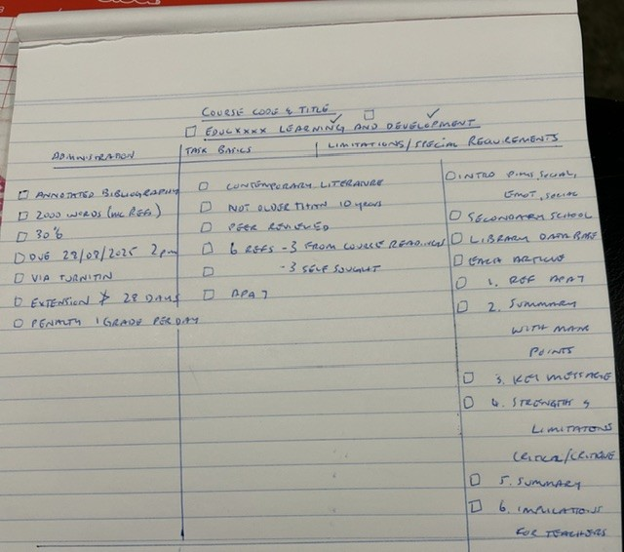
Table 1 shows you one way to display the important demands of the assessment task so you can work through them systematically and check them off as a final step before submission. Doing this before you start will etch the requirements into your mind and help you make the correct decisions on the resources you need to consider. You can’t start yet, though … the next thing is to develop procedural questions for yourself arising specifically from the detailed task sheet, and then tick them off as you get answers, for example:

- Do I know how to submit via Blackboard using Turn It In?
- Do I know how to find and use the Library Databases?
- How many days, weeks, and classes will I have to complete this? What is my personal deadline?
- What is the best contact for my questions?
- Do I have competing assignments for when this is due?
- Are drafts acceptable? If yes when is the last time I can ask for review of a draft?
- What course readings can I review for the first 3 annotations?
- Are graphics allowed?
- How many words will I need to write for each section of the assignment?
  - Introductory summary: 200 words
  - 6 articles: 200 words each = 1200 words
  - Each with 40 words summary, 40 words main points, 120 words critique
  - 6 full citations: 20 words each = 120 words
  - Closing summary: 200 words
  - Implications for teaching: 200 words
  - 80 words spare for title and headings
- What similarity score is acceptable?
- What use of AI is acceptable?

[It’s going to be tight, remember one A4 page is about 250 words so the whole assignment will be about 8 pages]

Final thing before you start: Go to your table and re-read the restrictions/ limitations/ special instructions. In this case, you should focus on the requirement to find 3 peer-reviewed articles published in the past 10 years (since 2016) that focus on Secondary students and address both learning and development. That ought to narrow the field quite a bit. This might be hard and time-consuming, so you must list your task to find articles as a very early task. If you leave it until later and then accidentally run out of time, you might get into trouble trying to race to find and absorb three articles to use.

You have done a lot of thinking to this point, but you still have to check out the marking rubric (see Table 2) before you properly start planning your paper. We will check it in detail later, but for the moment, the need is to find it and identify the criteria for assessment

The example criteria sheet is a bit unique in that it has so many criteria. Most of the ones I’m familiar with have only 3 or 4. However, this one has effectively broken down the main criteria into smaller parcels. I have shown how these are typically grouped, with one criterion for knowledge, one for argument, and one for communication. The beauty of Table 3 is that it shows useful details on the types of elements being judged and the pass mark. A well-developed criteria sheet/rubric might also show the weighting for each criterion, which will help you to know where to put most of your effort…. And now you are ready to start!

Ideas generation
This is your opportunity to conduct a comprehensive personal data collection by documenting your initial thoughts and knowledge on the subject. For the example assignment you would begin by gathering all the relevant information that you believe should be included in your assignment. You should reflect on key aspects, such as foundational concepts that underpin the field, influential researchers who have made significant contributions, and controversial topics that often lead to spirited debates. Additionally, consider popular ideas and theories that resonate strongly within the realm of learning and development, as they can provide a rich backdrop for your analysis and arguments.

For instance, when I was preparing for the example assignment, I sought assistance to help organize my thoughts. I specifically requested help in generating a visual mind map that encompasses concepts related to learning and teaching for secondary students. While I do not advocate using ChatGPT to outline or structure your entire essay, it can be an invaluable tool for brainstorming and refining your ideas. It allows you to visually capture your thought process, which can be beneficial when navigating complex topics.

In response to my request, ChatGPT produced an image that I have included as Figure 2. This figure illustrates various fields of inquiry and subtopics that could be relevant to the assignment at hand. Based on the task analysis for our example, you would need to select three specific areas to explore further to meet the task requirements. Therefore, you would have the option to choose from the seven categories depicted in the ChatGPT mind map, allowing you to tailor your focus to your specific interests and the requirements of the assignment. This structured approach can lead to more organised and insightful writing.
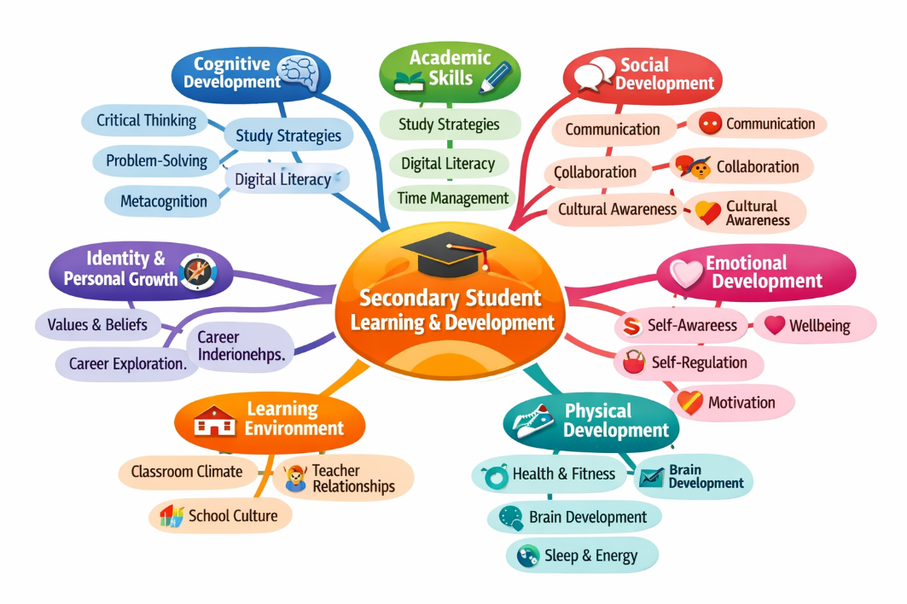
Figure 2 ChatGPT generated mind map for the example assessment task

To accompany and facilitate the refinement of this process, take a few minutes to skim through your lecture notes and any supplementary materials. This will help refresh your memory and clarify what "learning and development" specifically refers to in the context of this course.

As you gather your thoughts, consider using different techniques for visualization. Mind maps can help show relationships between concepts, while concept maps can provide a more structured overview of topics and subtopics. Tables may also be useful for organizing information in a clear and concise manner.

Make sure to focus on how these various elements interconnect and contribute to the broader understanding of the subject. Once you have created your visual representation and captured your ideas, set your work aside for now. This will allow you to approach your assignment later with a clear mind and a solid foundation of knowledge.

Table 2 Marking rubric/ Criteria sheet

.
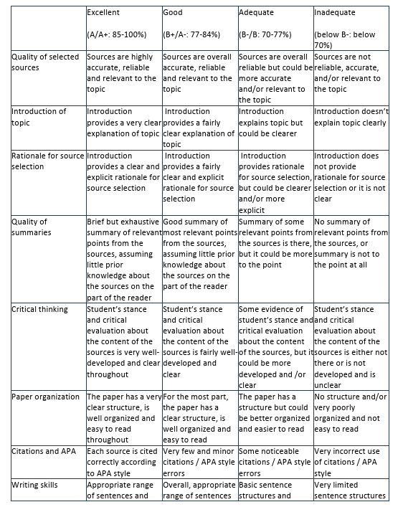
Knowledge
Argument
Communication

Chapter 2: Who can help?
A brilliant aspect of the modern tertiary sector is the development and provision of oodles of pathways to get help, but you can’t leave your help-seeking until the last minute. There is NO stigma to asking for help. So you might as well ask for it.
Your course team: lecturer, course coordinator, tutor. These people have intimate knowledge of the assessment task and are literally paid to help. The lecturer is usually allocated two hours or so each week for student consultation. You might need to book a time with them, but don’t be shy. It’s their job! If you have been unable to find answers to any of your “before you start” questions, then these are the first and best human resources for you. Things like contradictory guidance from the task sheet to the guidance information given in class are all things for you to refer to the course team.
Learning advisers: specialist educators skilled in task analysis, general written expression advice, and assignment planning. They often live in the student union or provide an online chat service.
Student counsellors: if you have any personal needs, learning difficulties, disabilities, emotional problems or medical restrictions, then these people can tee up with the course team on your behalf to get the consideration you need. This is a free and open service. No need to be brave and struggle through. If you need help and a little leeway, then these services are made for you.
Librarians: these staff are invaluable for helping you to find references and resources for your assignment. They have magical skills with hunting databases and can give you the results of comprehensive sources to support your assignment preparation. You can book a meeting, and they will walk you through.
Peer tutors: Most Universities have some sort of peer support system. These are usually senior students who have been where you are, who typically have successfully completed the very assessments you are facing. They can offer an online chat service, run study groups, or provide individual online or in-person consultations. If you are hoping to feel confident, then these systems are ideal.
Online help: Universities have comprehensive student portals that have resources to support every kind of assessment you can dream of. If you can’t find them, then go back to the librarian or IT help desk, and they will sort you out.
Study centres: councils in your city often provide study spaces for tertiary students, usually equipped with technology, reprographics, and human helpers, as well as snacks.
Public library: Libraries are well-equipped these days. If you need a quiet space to focus then you can usually find study rooms for just you or for a study group to work in for as long as you need. Libraries offer free wifi and are usually centrally located near food courts and cafes.
Your family/friends: they might be able to give academic support, proofreading, or just listen to you vent. If you need support to help you self-regulate your study time, then there’s always family or roommates who can be tasked to watch the clock for you.

Pace yourself
Don’t leave your help-seeking activity until the last minute. You need to schedule it in tandem with your work up of a timeline for your project. If you have learning support needs, signal that with the counselling service as the early stages of your assignment planning. If you need librarian support, then you need to seek that as soon as you have engaged fully with the task sheet. There’s no point in meeting with them if you don’t know the type of information you need. I have created a rather generic table (Table 2) to show you what might work for most assignments.
Table 3 Support timetable
Weeks before due | Task stage | Support needs  Course team relevant at all stages
6 weeks | Task analysis | Counsellor for any special arrangements you might require  Learning advisor for task analysis support
5 weeks | Resource finding (6 papers for annotated review) | Librarian (specialist)
4 weeks | Dot point plan  Introduction draft | Learning advisor/ Peer tutor  Online help, AI for grammar check
3 weeks | Sketch outline  Reference list | Peer tutor/ studiosity
2 weeks | First full draft | Family/friends Proof reading
Last week | Final submission  [extension application if needed] | University Health Service, Central extension repository.

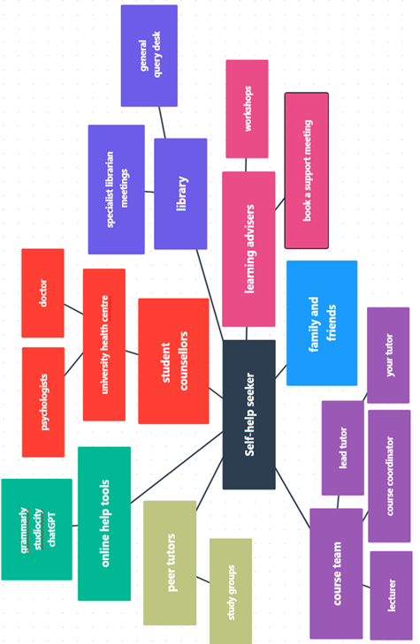
Figure 3 A network of support for you as you work on your assignment,

Chapter 3: Starting Your Draft

structuring and sequencing
A strong assignment submission is one that is logically and coherently structured. Every piece of writing consists of three parts: the introduction, the body, and the conclusion. While this may not be surprising, it’s important to understand the purpose of each part in relation to the argument you are presenting. Yes, I said argument. Bear with me while I digress for a moment.
The importance of the argument
Every piece of academic writing makes an argument. Many students overlook this and write as if they are merely describing something to someone who is completely unfamiliar with the subject or simply repeating information to someone who already knows it. It’s a bit like a kid on a bike screaming “look mum no hands” in this case the analogy would be “look mum, I know stuff” which lacks the sort of authority we need for a truly mature discussion. Those who fall into this pattern tend to be overly descriptive. Instead, they should aim to establish authority, justify their claims, and guide the reader toward a conclusion, rather than just providing information. Authority is what differentiates a good essay from an excellent one. And we start to build authority through the careful structuring and sequencing of our ideas.
Including rich descriptions and detailed explanations in your writing is essential for effectively communicating your ideas, but there is a limit to what you should include. Too much detail can obscure your argument, and too little detail or reliance on description rather than analysis can undermine your authority and distract from your message. When crafting your work, you should consider your audience—specifically, an intelligent adult who may not have extensive knowledge of the topics you are discussing. It’s possible that they may not be familiar with the specific academic papers you mention, nor are they likely to recognise pivotal figures in the field of your paper.
To bridge this knowledge gap, it’s crucial to provide enough context and background information so that your readers can appreciate the validity and significance of the referenced studies. This might include explaining key theories or concepts that researchers introduced, such as the importance of social interaction in the learning process or the notion of the Zone of Proximal Development if you were reviewing someone like Vygotsky (ref). By doing so, you help your audience understand not only the main ideas but also how they relate to your arguments.

If you’re unsure whether you’re offering too much or too little detail, a helpful strategy is to simplify your content. After doing so, seek feedback from a friend or family member to see if they can still identify and comprehend your main points. Their insights will guide you in refining your writing. Always remember that the clarity and strength of your argument are what truly matter in engaging your readers effectively. So back to structuring and sequencing…
The Introduction: Opening statement

The introduction serves to immediately lay out the territory the paper will address. It should start with a potent observation, a problem statement, or a clear summary of the intent for the argument for the paper. Here are some examples:
“Contemporary education is over-reliant on technology, and students are failing to become independent critical thinkers as a result.”
Of course, this example is a controversial statement, but whether they agree or not, at least the reader knows what they will be reading about. We know from this statement that critical thinking will be a key issue, and that evidence will be provided showing problems with how technology supports the development of critical thinking. Here’s another potential opening statement example:
“Mathematics anxiety hampers the development of mathematical skills for secondary students, especially girls”
This topic may not be as controversial, but the opening statement clearly states the problem to be addressed. From the very beginning, readers know what the paper will discuss, which is a departure from older traditional publications. In the past, authors tended to hint at the problem, guiding readers toward a central claim while leaving them in suspense about the essay's main argument. In my opinion, it's better not to keep readers guessing about the essay's focus—let them know upfront what it will be about.
A wise academic once told me that effective communication requires repetition: you should tell people what you are going to do, then do it, and finally tell them what you have done. This is essentially the approach we will be emulating here. The introduction informs the reader of the paper's main topics. However, it's not enough to just make an opening statement and think, "My job here is done!" You need to provide additional details about the key points that will support your argument.
The rest of the introduction
The introductory paragraph should provide details about the topics that the paper will discuss. For our first example statement above, this could include mentioning the types of technology that have emerged in schools and emphasising the importance of critical thinking. The introduction could culminate in a statement that connects technology to critical thinking, leading into the essay's main body. I mention it here, but in actuality this will be the last part of your assignment that you will write.
The middle
The main body, or middle section, is where many people tend to go wrong in their writing. They often ramble, presenting theories and ideas that can sound like a jumble of words. They may combine various thoughts into one long, convoluted paragraph, leaving the reader unsure of what to believe. Instead, you should start by developing a bullet-point plan. Outline the key messages you want to convey, the evidence you have to support your claims, and how these points connect to each other. This bullet-point plan will help organise your thoughts effectively. If you prefer, you can expand the plan into headings to guide the reader through your argument. Make sure to include all the details you intend to discuss, paying attention to how you will build and justify your argument through the points you raise. After outlining your main points, you can then focus on crafting your conclusion.
For the example assignment, you are required to conduct a thorough review of six selected articles. Your task involves several steps: first, you will introduce the articles collectively, providing context about their overarching themes and relevance to the field. Next, you will analyse each article individually, highlighting its key arguments, methodologies, and findings. Finally, you will summarise these insights with a specific emphasis on their implications for teaching practices. Additionally, please ensure that you reference specific policy documents related to the topics discussed in the articles, as these will be essential to substantiate your analysis and recommendations.
The conclusion
The conclusion paragraph serves to remind the reader of the key points discussed throughout the text and to reflect on the problem statement presented in the introduction. No new information should be introduced in this section. Essentially, this is where you assert, "I've proven my point," regardless of what that point may be.
Planning your essay
Your dot point plan will develop much like a jigsaw puzzle. Most people begin a jigsaw by completing the edges, then segment the picture's inner parts into zones, leaving the more difficult, undifferentiated areas (like the sky) for last. This serves as a useful metaphor for our dot point plan. What will be the defining edge of the paper, or its scope? What are the distinguishable contributing zones, and which areas are more challenging to categorise? Once we identify these elements, we can fill in the details until the picture is complete, allowing us to reflect on the overall depiction.
The smallest argumentative unit in an essay is a phrase. Phrases join together to make sentences, and sentences make paragraphs. Paragraphs link together to address a key message. No concept should be a dead end or orphan, and no sentence should exist without connection to the sentences around it. I’m reminded of the song, “the knee bone’s connected to the leg bone”. The sentiment of this song is pretty much a depiction of the way your paragraphs will link together.
Figure 3 shows the embedded structures for a typical essay, and in this case shows the papers to be reviewed for the example annotated bibliography assessment task we have been working on. I’ve colour-coded the major sections. Note that the papers to be reviewed are identified as list a or b. This is to reflect the requirement to select three papers from the set readings (list A) and three from your own search (list B). I have arbitrarily decided to have two papers each for three topics in the field of learning and development. How this pans out will depend on the results of your search.
To enhance your research, use search terms derived from the three readings you've selected or from your mind map. Limit your search to papers published in the past ten years (from 2016 onward if you are doing this in 2026). Validate your findings using the following criteria:
1. Peer-reviewed: Confirm that the paper has undergone peer review by checking the inside front cover of a recent issue of the journal in which the paper is published.
2. Journal Impact Score: This information is typically found in the front section of the journal or on platforms like Web of Science or Clarivate. The impact factor is a useful metric for comparing journals based on their rejection rates for submissions and citation counts of their papers over a two-year period. It is calculated by taking the number of citations from the past two years for articles published in those years and dividing it by the number of articles published. An impact factor between 5 and 10 is considered very good, while a score above 10 is outstanding.
3. Citation Score: This refers to the number of articles that have cited the paper in question. Sometimes, a paper may exceed the general impact of the journal in which it appears.
4. Text Quality: Ensure the paper is not merely a compilation of concepts that provides a general overview of a field of study. Such texts tend to be descriptive and often lack depth and engagement with the subject matter.
By following these established guidelines, you can enhance the relevance and quality of your research materials significantly. After you have carefully chosen three papers for both lists A and B, take a moment to double-check that each paper aligns with the specific criteria set forth for your assignment. Once you are confident in your selections, it is important to resist the urge to second-guess yourself or continue browsing for additional papers.
While it may be tempting to think that you might find a superior paper, continuing to search can often lead to feelings of anxiety and uncertainty about your choices. Remember that the research process is designed to help you learn and grow, and part of that process is trusting the decisions you’ve made. Embrace what you have selected and move forward with your work, as this will ultimately lead to a more focused and productive research experience.
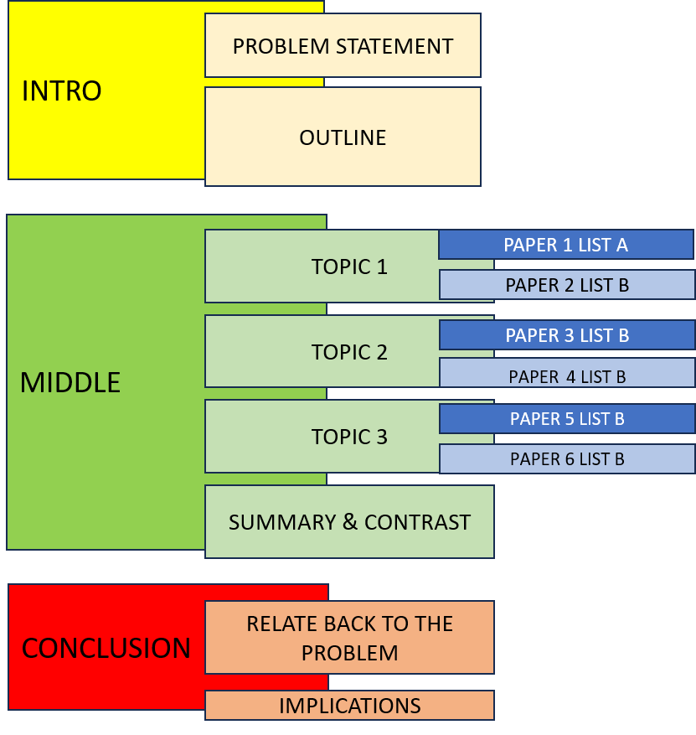
Figure 4 The outline structure for your essay

Linking and leading
Read and note the important observations for each of the selected papers. Begin by reviewing the title, conclusion, and abstract before diving into the entire paper. Consider the following questions: What is the main topic of the paper? What approach did the authors take? Who were the participants involved in the research? What is the central message of their findings?
Then, begin your critique. How reliable are their findings? Can their conclusions apply to a wider audience? Do their views align with popular opinions? Has anyone cited their work, and what did those citations say? (You will need to find these other papers for reference.)
Follow this process for each of the five other papers you select. If your assignment isn’t an annotated bibliography, use the same approach, but also compare the papers with one another. Create headings to organise your review observations. You will then be ready to fill in the details for each heading. Also, include a comparison of the papers as an additional step. From this work, generate headings to highlight your review observations. You will then be well-prepared to fill in the details under each heading.
Many beginners make the mistake of saying that a paper has a claim it doesn’t actually make. This often happens when students read only the title and jump to conclusions without reading the whole paper. I've seen students assume an author's point based only on the title and completely misinterpret what the paper is about. It’s very important to fully understand the main message of any paper you plan to cite.
Using headings
Whether or not you include headings in your final submission, make sure to use them in your draft. You can remove them later if needed. Headings help you stay focused on your argument and guide your discussion. However, they should not replace clear connections between your paragraphs. You should be able to take out the headings without leaving any gaps in your argument.
Showing authority
It's important to maintain a strong voice in your writing to clearly communicate your ideas. You can achieve this by using reliable sources and evidence to support your claims. Remember, as the writer, you control the message. This control will show in your writing when each paragraph connects to your main argument.
Every paragraph should have a purpose and directly support your main message. If a paragraph does not clearly contribute to your thesis or argument, consider removing it. Such paragraphs can distract from your writing and take up valuable space. If you struggle to remove a paragraph you think is valuable, take time to revise it. Rewrite it to clarify how it relates to your main argument. By doing this, you will improve the flow and effectiveness of your writing and strengthen your overall message.

Chapter 4: Using literature

to quote or not to quote
Many people think that quoting literature shows they understand their subject well. However, this is not true. Using someone else's words instead of your own suggests you lack confidence in your ideas. It also weakens the authority you want to have as a writer.

There are two common ways people misuse quotes that can harm their credibility:

- First, some people use long block quotes with little context, simply saying, “Xxx has said (insert quote).” While this does give credit to the original author and avoids plagiarism, it also shows that the writer couldn't express their thoughts in their own words.

- Second, some writers place phrases or terms in quotation marks. This approach has the same negative effect as the first but is even worse because it suggests they lack confidence in forming their own sentences about the topic.

When should you use a quotation? You should include a quote only when you need to analyse it to support your argument. Ensure that the quotation complements your own writing rather than replacing it. As a general guideline, write about the quote for at least as long as the quote itself. Be certain that the quotation is essential to reinforce your message, not as a substitute for your own writing. As they say, pull up your britches and trust yourself.

good literature and bad literature
It's important to understand which sources are not suitable for academic writing. Research and scholarly work can be divided into three main types of literature: academic sources, grey sources, and trash.
Academic literature is essential for strong scholarly work. These sources must be valid and verifiable, coming from credible, peer-reviewed journals or publications. This process ensures that experts have carefully evaluated the research, confirming its reliability and quality. Examples of academic sources include journal articles, books from university presses, and conference papers that contribute to ongoing scholarly discussions.
In contrast, grey literature includes a variety of documents that, while useful and sometimes verifiable, do not meet the strict standards of academic sources. These materials can provide important context but might lack thorough peer review. Examples of grey literature are policy documents, government reports, theses, working papers, and legal proceedings. While grey literature can add depth to your research, use it wisely and consider it a supplement to academic sources.
Trash sources fall into a separate category; they lack verified merit and cannot be trusted in academic work. These sources should not form the basis of your arguments. While you may cite them to illustrate a point or provide background, they do not stand up to academic scrutiny. This category includes magazines, newspapers, personal blogs, social media posts, advertisements, and similar media that often prioritise sensationalism or opinion over factual accuracy.
To maintain the integrity and credibility of your work, consistently use academic sources in your writing. Although trash literature might seem attractive because of its easy format or engaging content, the risks of using these sources in academic research outweigh any benefits. Always prioritise credible academic literature to support your arguments and claims. This practice will improve the quality of your work and protect your reputation as a serious scholar.

plug and play citations
Now this is a pet hate of mine. There is a tendency for students who are trying to appear well-read to simply add a reference to a passage without actually integrating the source into their discussion. Here is an example of the problems I’m referring to:
“A popular contemporary debate in the field of education is the issue of class size (Peters, 2023).”
You can see here that Peters has just been attributed to this idea. It’s not a quote, thankfully, but there is no justification for why the reader ought to have any interest in Peters. The discussion doesn’t provide any suggestion that Peters’ perspective is informed. It seems as though the citation has just been plucked out of the air. But there is a greater sin, the sin of the party citation.
In a party citation, the student lists several papers in a compendium or list without any justification or evidence that the various authors are aligned. Here is an example of a party citation:
“Investigations into the impact of physical development on learning have consistently found that they are inextricably linked (Roberts, 2025; Thies & Walker, 2023; Yip and Yang, 2020).”
As you can see, the student here has added to my complaint about unjustified citation, and has taken one further step into the abyss by referencing three separate papers as though they all have the same findings. They might, they might not … the argument needs to be directly established.

using literature without plagiarism
Plagiarism is a serious accusation, and students often find themselves unwittingly falling into its trap. This occurs when they gather ideas from various sources while simultaneously writing. The information they read can become embedded in their minds, leading to unintentional copying in their own work. To avoid this risk, it's important to incorporate the details of your argument and sources into a draft using bullet points. This approach will make it easier for you to paraphrase later on without inadvertent plagiarism.

Using AI, traps for new players
The impact of AI on authorship is profound and multifaceted. Authors can now leverage AI interfaces to transform their ideas into coherent and compelling text passages. These tools are capable of drafting entire essays, allowing writers to focus more on their core concepts and creativity. The ease with which one can produce grammatically correct and engaging written material has never been greater, thanks to the advancements in AI technology. However, despite its many benefits, there are significant concerns that need to be addressed.

One of the primary issues with AI-generated content is its tendency to "hallucinate." This means that the AI may inaccurately reference literature or studies that do not exist. It can lead to incorrect attributions of ideas to authors, the inclusion of outdated articles, or misunderstandings of complex theories. This problem arises because AI systems retrieve information from a wide array of sources on the internet, many of which contain misinformed or poorly researched content. As a result, the reliability of the information generated by AI can be questionable.

Given these challenges, I believe that the safest approach to using AI in the writing process is to take an active role in crafting your text. Write the initial draft yourself to maintain creative control and ensure accuracy in your ideas. You can then use AI tools specifically for proofreading, such as checking for spelling and grammatical errors, to enhance your work. By combining your own insights with AI's editing capabilities, you can create high-quality content while minimizing the risks associated with relying too heavily on AI-generated material.

AVOIDING THE SHOPPING LIST
Using literature to create and support your argument in an essay is an art. One major sign that an argument lacks maturity and authority is when it resembles a "shopping list." This occurs when the student simply lists a series of ideas, often drawn from different bodies of literature or individual papers, without providing commentary or linking them to a central idea. As a result, it is left to the reader to navigate these leaps of logic.
In the text box below, I have illustrated the progression from a shopping list type of essay through various stages of maturity. The first improvement is the integrated discussion. In this case, the ideas are sequenced in a timeline format, but there is still no real argumentative linkage between the citations. The next step for improvement is the argued case without a resolution. Here, there is some contrast between the ideas presented from the literature, but the reader is still left to form their own conclusions about the key message. The final step in maturity is the definitive case. In this ideal form, the selection of literature is justified, the sequence of idea development is presented clearly, and the reader is shown the argumentative intent behind the authoritative argument's key message. As you read through the examples in the text box, take note of an important observation. … the word count has not really expanded much—from the shopping list (39 words) to the definitive case (79 words).
The shopping list
On the topic of healthy shopping, I found a paper by Milo (2021) who said that milk was a necessary purchase. Orange (2019) has argued for bottled water. Teabag (2022) found that both water and milk were good purchases.

The integrated discussion
Milo (2021) has reported research that suggests the value of milk in a shopping order. This built on Orange’s earlier finding (2019) in prominent research focused on the importance of fruit juice in a healthy diet. By contrast, Teabag (2022) has more recently reported that both water and milk were good shopping purchases.

The argued case without a resolution
The importance of careful beverage choice when shopping cannot be overemphasized. There have been several significant studies investigating the health benefits of purchasing water or milk in a shopping order. Most recently, Teabag has argued that there is no discernable distinction between them, putting to rest the cases mounted by Milo (2021), who argued strongly for milk, and Orange (2019) who argued for juice.

The definitive case
Although several writers have researched the health benefits of water or milk as a key component of a shopping order (e.g., Milo, 2021; Orange, 2019) the conclusive case has been determined by the most recent research by Teabag (2022). Teabag found, through an extensive survey study with health practitioners that there is no firm distinction between them. This research identified weaknesses in the previous research programs in that the findings were based on customer opinion rather than professional insight.
You now have all the information necessary to write your essay, and if you've been following along, you should have a completed first draft. This means you are two-thirds of the way to submitting your work. Now, let's focus on polishing it. As a good friend of mine puts it, it’s time to add the salt and pepper.

Chapter 5: finishing touches

spelling
The most important step is to check your spelling. If your paper is riddled with spelling errors, you are undermining your own work. It clearly indicates to the reader that you have not paid attention to detail and serves as a surefire signal for a low grade. Make sure to turn on your spell checker, set your language to English (Australia), and actively correct any errors highlighted by the spell checker.

grammar
As for spell checking, it’s also important to run a grammar check. My method is to select a paragraph and run it through a grammar checker. I accept all suggested changes and then review the text closely to ensure that no meaning has been lost.

citation conventions
It’s crazy to lose points because you haven’t paid attention to the required citation conventions. Whether you are using the Harvard referencing system, APA7, or any other convention, you need to make sure that every minor detail has been attended to. Extend your scrutiny to requirements for font, page format,

the linking game
A well-constructed essay will have a comprehensive set of linkages. The main directional linkages connect each point in a linear fashion, allowing one idea to lead to the next. However, supplementary linkages are also important; these linkages constantly refer back and forth between points, enhancing the overall meaning and intent of the essay.

As topics are discussed, they accumulate and contribute to a snowball effect that leads toward the summary. In the concluding paragraphs, these links should reflect back to the introduction and the opening problem statement. It resembles a game, where the goal is to connect every message not just to the previous one, but also within the overall structure of the essay.
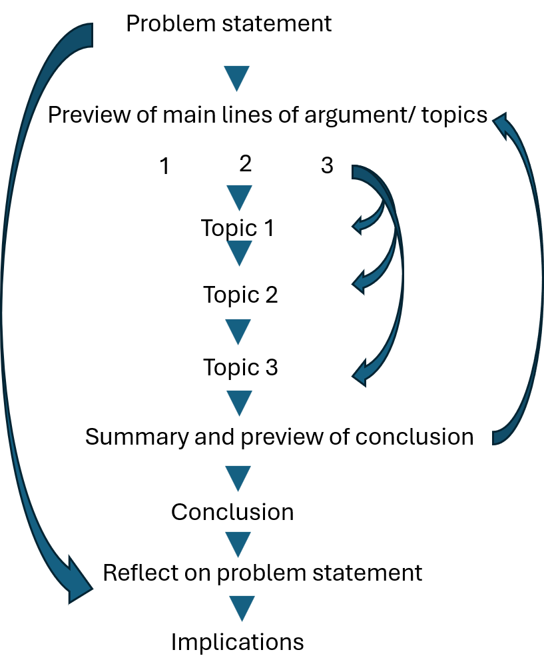
Figure 5 Conceptual linkages

start at the end and read your Draft backwards
Before submitting, a helpful trick to catch any typos is to read your document backwards, starting from the end and working your way to the beginning. It's surprising how many mistakes you can spot this way. Finally, double-check the criteria and refer back to the checklist table you created at the beginning. If possible, ask someone to read the assignment for you. Consider reading your paper aloud to yourself and taking a 24-hour break before submission. Do one more read-through before pressing the submit button.
I hope the advice provided in this guide is helpful. Best wishes!

APPENDIX A: Nan’s rule book
(in no particular order)

#1 Always start by identifying the problem and why it is one

#2 Only use literature when you have explained its value

#3 Think twice before using a quotation

#4 Grammar check

#5 Paragraph structure is topic sentence, build, summary and link

#6 A paragraph is a single argument

#7 Sentences deal with one idea only

#8 Tell the reader what you’re going to do, do it and tell them what you did

#9 If it’s in your discussion, it’s in your reference list

#10 List in text citations alphabetically by first author

#11 Always mention acronyms in full the first time

#12 Numbers under ten (10) in words and brackets e.g. nine (9)

#13 Proofread

#14 There shall not be any typos

#15 Read you paper out loud (or silently) doing all the voices at least once before pressing submit

#16 More than 30% similarity check is criminal

#17 Due date is two days before due date

#18 Make it count or leave it out.

POSTSCRIPT
Emeritus Professor Nan Bahr is an esteemed Australian academic researcher and educator with a national and international reputation for her contributions to teacher education, adolescent learning development, and responsive schooling, particularly in the middle years of education. She holds undergraduate and postgraduate degrees in education, psychology, and music education.

Professor Bahr is affiliated with Southern Cross University, where she previously served as Deputy Vice Chancellor (Students). She is also a Course Coordinator for Initial Teacher Education and Graduate Education programs at The University of Queensland, and mentors early career academics at The University of Southern Queensland. Additionally, she holds the position of adjunct professor at Griffith University and Queensland University of Technology.

With her extensive background, she is exceptionally qualified to provide guidance on essay writing for students enrolled in contemporary programs.



[https://itali.uq.edu.au/teaching-guidance/assessment/designing-assessment/course-profile-assessment-attributes]
including project proposal, various types of report (e.g. design, lab etc.), conference paper, case study, journal, literature review, plan, team charter, etc. Essay/ Critique
You might like to start up a pocket notebook to capture random ideas that might leap into your head before you are ready for them.

